Mating Preferences and Short-Term Mating Behavior:
A Simple Agent-Based Model of Sex and Sexual-Orientation Differences

Yurun Ying,¹ Jan Antfolk,² and Pekka Santtila¹
¹ Faculty of Arts and Sciences, New York University, Shanghai
² Department of Humanities, Åbo Akademi University

Sex differences in reported short-term mating behavior are a recurring empirical pattern in human sexuality research. Across many survey-based studies, heterosexual men report (on average) more short-term sexual partners than heterosexual women (e.g., Oliver & Hyde, 1993; Petersen & Hyde, 2010; Rissel et al., 2014). Similar differences have also been documented between gay men and lesbian women, with gay men typically reporting higher rates of casual sex and a larger number of partners (e.g., Bailey et al., 1994; Peplau et al., 2004).
At first glance, these behavioral differences seem to fit a well-known idea from evolutionary psychology: if men are more motivated than women to pursue short-term mating, then we should see more short-term mating among men (Buss & Schmitt, 1993, 2019). But for heterosexual encounters, there is a built-in constraint: each new short-term encounter involves one man and one woman, and therefore increases the number of short-term experiences for men and women by exactly the same amount in the population as a whole (Archer, 2019; Symons, 1979). This raises a basic question about what conditions might be necessary for sex differences in short-term mating preferences to produce sex differences in observed short-term mating behavior.
We explore this question using a deliberately simple agent-based model of mate search, short-term mating, and long-term relationship formation in a closed population. In the model, individuals differ only on a small set of features that capture two components of short-term mating preferences. The first is their general willingness to engage in short-term mating. The second is how selective they are about their partner’s “desirability.” This latter attribute is a simplification that compresses many real-world attributes (e.g., attractiveness, status, kindness) into a single number that agents can use when making decisions. We compare heterosexual populations to same-sex populations (gay men and lesbian women) in order to shed light on a key constraint in the heterosexual case: the need for cross-sex agreement in the face of known male/female differences in short-term mating preferences. This constraint does not exist in same-sex populations.
Specifically, two experiments were undertaken with the same core model. Experiment 1 simulated a heterosexual population in which males and females seek mating partners of the opposite sex. Experiment 2 simulated a population of gay males and lesbian females in which agents seek partners of the same sex. In both experiments, we used a 2 × 2 design that manipulates whether males and females differ in (a) their willingness to engage in short-term mating and (b) their minimum desirability standards for short-term mating partners. Model parameters and the values employed for them are summarized in Table 2.
The model and initial simulation results were first reported in Ying, Antfolk, and Santtila (2024). The goal here is pedagogical: we reorganize the model description for readers who are new to agent-based modeling, highlight the central qualitative patterns from the simulations, and end by suggesting concrete ways that readers can explore, extend, and repurpose the model to address other questions.

Method
The model represents a “chance encounter” process in which agents move randomly in a two-dimensional space, occasionally share a location with others, and may then initiate either a short-term mating encounter or (with some probability) a long-term relationship. Short-term mating is defined in the model as a one-time encounter between two agents who (a) meet each other’s minimum desirability standard for short-term mating and (b) are both willing to engage in short-term mating. The formation of long-term relationships reduces agents’ active partner search activity and their availability in the short-term mating market.

Environment
Agents live on a square lattice of patches (a discrete two-dimensional space). A patch does not correspond to a literal physical location (e.g., a bar or a neighborhood block). Instead, patches are simply a convenient way to implement local encounters: agents can only directly “meet” other agents who are on the same patch. Time is also abstract. One tick represents a generic opportunity cycle in which agents may move, potentially encounter other agents, and possibly form short-term or long-term relationships.
Spatial movement is bounded by an agent’s movement range around its initial birthplace. This maximum distance is controlled by the interface parameter movement-range. Limiting movement in this way is intended to produce repeated local mixing: agents have space around their birthplace to engage in random mate search, but do not encounter partners from the full population with a uniform probability.

Agents and Their Properties
Each agent is a turtle, and represents an individual person. Agents have an assigned biological sex (male or female), and a sexual-orientation setting that determines which sex they consider for potential mating partners. The global switch all-homosexual? on the model interface controls whether the population is strictly heterosexual (when set to “Off”) or consists only of gay males and lesbian females (when set to “On”).
Each agent also has a mating desirability attribute called desirability. This attribute is drawn at setup from a normal distribution with a mean of 5 and a standard deviation of 1.5, and has a minimum of 0 and a maximum of 10 (values lying outside this range are replaced by the minimum or maximum, whichever is closer).
Two additional agent properties represent their short-term mating preferences. First, each agent has a fixed probability of engaging in short-term mating. This is represented in the code by the variable willingness, and is determined according to the agent’s sex either by the male-willingness slider or by the female-willingness slider on the model’s interface. This variable captures an agent’s general “willingness” to engage in short-term mating; the higher the value of this variable, the more generally willing an agent is to engage in short-term mating. Second, each agent has a minimum desirability standard for short-term mating partners, represented by the variable desirability-standard. This variable is determined according to the agent’s sex either by the male-desirability-standard or female-desirability-standard slider on the interface. The higher the value of this standard, the higher a potential partner’s desirability must be in order for the two to mate. Note that in a given model run, all males have the same willingness value and the same desirability-standard value. The same holds for females. However, males and females may or may not have the same values as each other, depending on how the associated sliders are set on the model’s interface.
Finally, agents track their relationship status and mating history over time. Agents store whether they are currently in a long-term relationship (coupled?), who their long-term partner is (if any; partner), and how many short-term encounters they have had (short-term-count). The key state variables are summarized in Table 1.

Agent Action
On each tick, agents first determine whether they will move. Agents who are in a long-term relationship do not actively search (they stay in place), whereas single agents move stochastically within their allowed movement range. Movement is implemented by giving the agent a random heading and moving it forward by a random distance between 0 and half of the movement-range. If the agent has wandered beyond its permitted range, its heading is set in the direction of its birthplace.
Also on each tick, each agent sets its short-term mating preference. The Boolean variable short-term-mate? indicates whether it is willing to engage in a short-term encounter during the current tick. An agent sets this variable to “true” with a probability given by its willingness variable. This captures the idea that even someone who is usually very willing to participate in short-term mating may not pursue every short-term mating opportunity.

Agent Interaction and Decision Rules
In this model, an “interaction” is a highly stylized event. It entails an agent choosing a potential partner from among the other agents currently located on the same patch, both the agent and the potential partner checking to see whether the other meets its desirability standard for short-term mating partners, and then, if both are willing to mate, recording the encounter as an instance of short-term mating.
Heterosexual encounters are initiated by male and female agents with equal probability, with the restriction that on any given tick, either all of the males or all of the females are initiators. After moving, each initiator checks whether any other agents of the opposite sex are present on their current patch. If none are present, nothing happens. But if one or more are present, they select one of them at random as a candidate short-term partner. A short-term mating encounter occurs if and only if three conditions are met: (a) the female’s desirability is at or above the male’s desirability standard, (b) the male’s desirability is at or above the female’s desirability standard, and (c) both agents are willing to engage in short-term mating on that tick (i.e., their short-term-mate? variables both have been set to “true”). If any one of these conditions is not met, short-term mating does not happen on this tick, and instead the initiating agent selects from the same set of other agents on their patch a candidate long-term partner. The only restriction here is that the candidate (a) must be of the opposite sex and (b) must not already be in a long-term relationship. If these two conditions are met, then with a probability set by the interface parameter long-term-likelihood, the pair forms a long-term relationship.
In the gay male and lesbian female experiment, the same flow of events occurs, with one additional feature that helps avoid redundant checks. On any given tick, half of the male agents and half of the female agents are randomly chosen to be the initiators. Only initiators actively look for a partner on their patch. When an initiator chooses a candidate, it restricts attention to same-sex partners (males look for males, and females look for females). Short-term encounters and long-term pair formation then follow the same mutual desirability and willingness rules as in the heterosexual case.

Agent Updating
When a short-term mating encounter occurs, both participants increase the count of their short-term mating experiences (the variable short-term-count) by one. They also update a list of their unique past short-term partners (short-term-history) and track the length of that list (number-of-short-partners). Thus, the model tracks the number of distinct short-term mating partners separately from the number of encounters. This distinction matters because multiple short-term encounters with the same person would increase experiences without increasing the number of unique short-term partners.
When a long-term relationship forms, both partners update their relationship status: they become coupled and store each other’s identity. They also reduce their willingness variable to one-third its original value, representing a lower willingness to engage in short-term mating once coupled. In the baseline model there is no explicit relationship dissolution, so, once coupled, a pair remains coupled for the rest of the simulation. Because coupled agents do not move, long-term relationships reduce the number of agents circulating in the encounter space.

Initialization and Scheduling
At setup in the baseline model, an equal number of males and females are created. The male count is controlled by the number-of-males slider, and the female count is set to 300 minus the number-of-males. Thus, setting number-of-males to 150 yields a 1:1 sex ratio. Agents are placed at random locations in the view, which become their birthplace. Each agent is then assigned a desirability value, preference parameters, and empty mating histories.
Each tick then consists of the following sequence:
- Single agents move within their movement range; coupled agents stay in place.
- All agents decide whether they are willing to engage in short-term mating on this tick.
- Eligible agents choose a partner from among the others, if any, on their patch (opposite sex for heterosexual runs; same sex for same-sex runs).
- If both agents are willing to mate and if each meets the other’s desirability standard, short-term mating occurs and both agents update their histories.
- If short-term mating does not occur, initiating agents then attempt to establish a long-term relationship with a local partner, and do so with a probability given by the long-term-likelihood slider.

Outcome Measures
The model produces two primary outcome measures, computed separately for males and females:
- Mean number of short-term mating encounters.
- Mean number of unique short-term mating partners.
We report averages of these outcomes in two ways: (a) averages across the full population (n = 150) of each sex, and (b) averages restricted to just those in the mating pool. In the latter case, only agents with short-term-count > 0 are considered. Additionally, we also measure the size of the “mating pool,” defined as the proportion of agents of each sex with at least one short-term encounter (i.e., short-term-count > 0) in the experiment with a heterosexual population.
Simulation Experiments
As noted, we conducted two experiments with this model, one simulating an exclusively heterosexual population (Experiment 1), and one simulating an exclusively same-sex population (Experiment 2). Both experiments involved 150 male agents and 150 female agents, and in both we manipulated whether males and females differed in (a) their willingness to engage in short-term mating and (b) their minimum desirability standards for short-term mating partners. The values of these two parameters were chosen to be simple and empirically plausible. When the model included a sex difference in willingness to engage in short-term mating, males were always assigned a higher willingness than females (0.4 vs. 0.25, respectively), consistent with empirical work on sociosexuality and short-term mating motivation (Buss & Schmitt, 1993; Schmitt, 2003; Schmitt et al., 2001). When the model did not include a sex difference in willingness to engage in short-term mating, males and females were both assigned a willingness of 0.25. When the model includes a sex difference in desirability standards for short-term mating partners, males were always assigned a lower desirability standard than females (3 vs. 5, respectively, on a 0–10 desirability scale), which is consistent with evidence that men, on average, have lower minimum standards for casual partners than do women (Kenrick et al., 1990; Regan, 1998). When the model did not include a sex difference in desirability standards for short-term mating partners, males and females were both assigned a desirability standard of 5. For each experiment, the model was run 2,500 times with each combination of parameter values (10,000 runs in all), and each run terminated after reaching 1,000 ticks. The main results from both experiments are reported below. These results were also checked for robustness over alternative values of long-term-likelihood.

Results

Experiment 1: Heterosexual Populations and In-Pool Averages
A useful baseline check is the heterosexual population average. Because each heterosexual short-term encounter involves one male and one female, the population average number of short-term mating encounters accrued by males and females must match exactly. The same holds for the population average number of unique short-term mating partners. In the simulations, these constraints show up clearly. When we averaged across all 150 males and all 150 females, males and females accumulated an identical number of both short-term mating encounters and unique short-term mating partners, even in the condition with sex differences in both willingness to engage in short-term mating and in desirability standards. Both sexes averaged M = 1.43 short-term mating encounters and M = 0.80 unique short-term mating partners.
Although these averages were equal in the heterosexual case when considering the entire population, it is important to note that males and females did not participate equally in the short-term mating pool; fewer males than females participated. We define participation in the short-term mating pool as having had at least one short-term mating encounter during a given model run. As can be seen in Figure 1, in two of the four conditions of the 2 × 2 experiment, the one involving a difference in both willingness and in standards (marked DW/DS), as well as the condition involving the same willingness but a difference in standards (marked SW/DS), a noticeably smaller percentage of males than females had at least one short-term mating encounter. This is not because males were less willing than females to engage in short-term mating in these conditions. Rather, it is because their potential female partners had higher minimum desirability standards, which fewer of the males were able to meet. Likewise, the potential male partners of females had lower minimum desirability standards, which more of the females were able to meet.
But the existence of different desirability standards among males and females does more than just create sex differences in short-term mating pool participation. For those who do participate in the mating pool, it produces sex differences in mating behavior. Figure 2 shows the average mating behavior of just those agents who participated in the short-term mating pool (i.e., had at least one short-term mating encounter during a given model run). As can be seen, regardless of whether they had the same or different willingness to engage in short-term mating, when males had a lower desirability standard for short-term mating partners than did females (conditions DW/DS and SW/DS), they also had more short-term mating encounters (Panel A) and more unique short-term mating partners (Panel B). By contrast, when males and females had the same desirability standards, regardless of whether they had the same or different willingness to engage in short-term mating (conditions DW/SS and SW/SS), males and females had nearly identical numbers of short-term mating encounters (Panel A) and unique short-term partners (Panel B).

Experiment 2: Same-Sex Populations
The same-sex experiment removes the constraint that exists in heterosexual mating, because male–male and female–female encounters, by definition, involve agents with similar mating preferences. Here, sex differences in mating preferences translate more directly to differences in behavior that are manifest in the population as a whole (Figure 3). As can be seen, when gay males and lesbian females were equally willing to engage in short-term mating and had identical desirability standards (condition SW/SS), their short-term outcomes were essentially the same: about M = 0.32 short-term mating encounters and M = 0.25 unique short-term partners for both sexes). When we introduced a sex difference only in their willingness to engage in short-term mating (giving gay males a higher likelihood than lesbian females; condition DW/SS), gay males, on average, had 2.5 times as many short-term mating encounters (Panel A), and twice as many unique short-term partners (Panel B), as did lesbian females. When we instead introduced a sex difference only in their desirability standards for short-term mating partners (setting the standard lower for gay males; condition SW/DS), the gay males had just over 3 times as many short-term mating encounters and unique short-term partners as did lesbian females. But there was also a strong, synergistic interaction between these two factors, such that when males and females differed in both their willingness to engage in short-term mating and in their desirability standards (condition DW/DS), gay males had more than 8 times as many short-term mating encounters, and nearly 7 times as many unique short-term mating partners, as did lesbian females.

Comparing Gay and Heterosexual Males
A final comparison highlights the importance of partner preferences, not just one’s own preferences, in generating the observed results. Consider the condition with sex differences in both willingness to engage in short-term mating and in desirability standards for short-term partners (condition DW/DS in all three figures). When all males in the heterosexual population (not just those we defined as being in the mating pool) are compared to all males in the same-sex population, the gay males, on average, engaged in more short-term mating than did heterosexual males. Gay males averaged M = 2.63 short-term mating encounters and M = 1.72 unique short-term mating partners, whereas heterosexual males averaged M = 1.43 short-term encounters and M = 0.80 unique short-term partners. This occurred despite the fact that the male’s preference parameters (willingness and standards) were exactly the same across these populations. What drives this difference is the preference parameters of the males’ potential mating partners. The potential partners of the gay males (i.e., other gay males) were more willing to engage in short-term mating and had lower desirability standards (.40 and 3, respectively) than was the case for the potential partners of the heterosexual males (i.e., heterosexual females; .25 and 5, respectively). This made mutual acceptance of a mating opportunity more likely for gay males than for the heterosexual males.

Robustness to Long-Term Pair Formation
The qualitative patterns summarized above were not sensitive to the specific baseline value used for long-term pair formation. As reported in Ying et al. (2024), additional runs that varied the long-term-likelihood parameter yielded the same qualitative results: heterosexual male and female population averages remained equal, heterosexual mating-pool differences depended primarily on differences in desirability standards, and gay males exceeded both lesbian females and heterosexual males in their short-term mating behavior (both number of encounters and number of partners).

Discussion
This model illustrates a simple but easily overlooked point: in heterosexual populations, individual preferences alone are not sufficient to predict average short-term mating behavior. Because each heterosexual short-term mating encounter requires mutual agreement, male behavior is constrained by female preferences and availability, and female behavior is constrained by male preferences and availability. In a closed population with an equal sex ratio, this implies that the total number of short-term heterosexual encounters accrued by males and females must be equal. Accordingly, our simulations show that even when males are modeled as more willing and less selective, heterosexual males do not surpass heterosexual females in their population-average numbers of short-term mating encounters and unique short-term partners. In contrast, when we restrict attention to just the mating pool—those who have had at least one short-term mating encounter—sex differences emerge. In our simulations, higher female desirability standards, and so selectivity, produces a smaller subset of sexually active males compared to females. As a consequence, those males, on average, accumulate more short-term mating encounters and more unique short-term partners. This provides a clear demonstration of how “behavioral sex differences” can depend on the specific population from which the average is taken (the full population versus the sexually active subpopulation).
In same-sex populations, the model produces a different result. When potential partners are similarly short-term oriented, mutual acceptance becomes more likely, allowing short-term preferences to be expressed more directly in behavior. This yields higher average short-term mating among gay males than among lesbian females in the population as a whole, not just in the sexually active subpopulation. It also yields higher averages short-term mating among gay males than among heterosexual males, even when males’ own preference parameters are the same in these two populations. In other words, the partner market matters: changing who a person is trying to mate with can change the degree to which their mating preferences are realized.
It's worth noting that the model is intentionally designed to be simple. It uses a single partner desirability dimension, random local partner choice, and a simple mechanism that removes some agents from active search once they form a long-term relationship. Many real-world factors are absent, including long-term relationship dissolution, strategic behavior, learning, social networks, contraception, sexually-transmitted infection risk, life-history tradeoffs, and multidimensional mate choice. For that reason, the model should be treated as only a rough conceptual tool that clarifies which behavioral patterns are likely to follow from basic assumptions about constraints and preferences.

Engaging With the Model
We hope that the model described in this chapter is useful both as a teaching tool and as a starting point for your own modeling projects. Below we suggest several concrete ways to explore the model. The first set of activities requires no programming—only changing interface settings and running the model. The later activities involve BehaviorSpace experiments and/or code edits for readers who want to go further.

Getting Started
Because the model is stochastic, a single run can be misleading. For most of the activities below, we recommend running the model many times under the same settings. If you are exploring manually, click setup then go forever, run the model for a fix number of ticks (say, 500), and keep notes of the outcomes. Then repeat this process 10–20 times before drawing a conclusion.
The first set of activities aims at providing an intuition on how different preference structures can lead to the observed outcomes reported previously. Starting with the heterosexual model, you can manipulate the short-term mating standards of each sex. While keeping the male-willingness and female-willingness sliders fixed at a moderate value (e.g., 0.25), try fixing male-desirability-standard at 3 and gradually increasing female-desirability-standard from 3 to 7 (being sure to click setup then go forever each time you make a change). If you watch the plots on the model interface, you will likely notice three things. First, when the entire population is considered, the trajectories over time (ticks) for all measures are always identical for males and females. The percentage of agents that enter a long-term relationship (top-left plot), the average number of short-term mating encounters that agents experience (middle-left plot), and the average number of unique short-term partners they have (lower-left plot) are always exactly the same. Second, as the female-desirability-standard slider is increased from 3 to 7, the overall size of the mating pool decreases—a smaller percentage of both males and females have least one short-term mating encounter. This can be seen in the top-right plot. Third, despite the drop in the overall size of the short-term mating pool, the percentage of females that enter that pool tends to be higher than the percentage of males that enter.
You might also try setting the short-term desirability standards of the two sexes to the same value and vary the short-term mating likelihoods. Now you will likely see no consistent, observable sex differences in any of the plots. This tells us that, in heterosexual populations, the higher desirability standards of females drives down the overall number of active participants in the mating pool, but does so more strongly for males than for females.
Next, turn to the situation with gay males and lesbian females (by setting the all-homosexual? switch to “On”) and repeat the above activities. In this scenario you will see that when the entire population is considered (left-hand plots), the trajectories over time for the three measures are generally not the same for males and females. Moreover, when sex differences exist either in short-term mating likelihood or in desirability standards, males and females tend to differ more dramatically in their sexual behaviors, with males having many more short-term mating encounters and more unique short-term partners. This further illustrates the fact that the predilections and preferences of an agent’s potential mating partners can be a constraint on the behavioral manifestations of that agent’s own mating preferences. In particular, identical male preferences—higher willingness and/or lower desirability standards—translate into more frequent short-term mating encounters with more unique mating partners when those potential partners are other males (who share the same preference) compared to when they are females (who have more restrictive preferences).
A second dimension to explore is how the population sex ratio influences these outcomes. By default (i.e., when first downloaded from the book’s companion website), the model creates an equal number of males and females, but you can alter this balance by adjusting the number-of-males slider. You may wish to investigate how scarcity or abundance of one sex changes the size of the mating pool and/or the agent’s short-term mating behavior. Try decreasing the number-of-males while keeping the overall preference pattern constant. For instance, eliminate all sex differences in both willingness and desirability standards, then reduce the number of males in the population by half or more. You will see that males and females can behave differently as a sheer consequence of this skewed sex ratio. Building on this, you can systematically examine how the sex ratio interacts with differences in the short-term mating preferences (see also below). This type of exploration helps to clarify how structural factors like population sex ratio can either amplify or dampen the behavioral expression of individual mating preferences.
Finally, you may wish to explore the boundary conditions of the mating market by varying movement-range and the propensity to form long-term relationships, long-term-likelihood. The latter parameter influences how quickly agents are removed from the pool of those actively searching for a short-term mating partner. By testing a range of values from 0 to 0.50, you can identify the point at which long-term coupling begins to significantly reduce the total amount of short-term mating. Also notice whether any sex differences in mating behavior emerge at all when you increase long-term likelihood, and if so, how quickly they emerge. Similarly, the movement-range parameter dictates the transition from a local neighborhood structure of mate searching to a globally mixed market. Setting movement-range to a very low value (e.g., 1) forces agents into repeated encounters with a very limited set of nearby others. Setting it to a very high value (e.g., 15) allows agents to interact with a much larger percentage of others in the population. Varying this parameter will allow you to see if the qualitative patterns reported in this chapter remain robust under conditions of very local vs global mixing.
BehaviorSpace and Systematic Experimentation
Readers with just a little more experience can also explore the model using NetLogo’s BehaviorSpace tool. A BehaviorSpace experiment allows users to run the model a large number of times, and output the results of each run to a file that can be read and analyzed using any popular spreadsheet program. Users can decide to output either the results produced at the end of each model run or the results for each tick of each run. The latter will generate a much larger datafile, but also a potentially richer source of information for analysis.
Here are some possible directions you can explore. One is to reproduce the main results reported in this chapter. The code for these experiments is packaged with the model (go to Tools >> BehaviorSpace). You will find there eight separate BehaviorSpace experiments, one for each of the four conditions in Experiment 1 (the heterosexual case), and one for each of the four conditions in Experiment 2 (the same-sex case). Each of these will run the model 2,500 times. We recommend that you select “table” output when running them. After opening the output datafile in a spreadsheet program, compute the relevant means for each separate run (based on the counts and sums reported there), and then compute the grand means across all runs in the experiment. Those grand means should closely approximate the values we reported here.
Using BehaviorSpace you can also explore new parameter combinations or examine measures beyond the scope of this chapter. For example, you can systematically vary the number-of-males parameter and examine the effect of population sex ratio. In a male-biased (vs. female-biased) population, do higher female desirability standards usually result in an even more concentrated mating pool for males, or does the demographic imbalance typically overwhelm the effects of individual standards? How does a skewed sex ratio affect the sex differences in mean short-term-count and number-of-short-partners?

Simple Code Modifications
Finally, we encourage readers who are comfortable with coding to explore and modify the code underlying the model. For example, in the baseline model, the probability of two agents forming a long-term relationship is controlled by a single global probability set by the long-term-probability slider on the model’s interface. One alternative is to make long-term relationship formation agent driven. You might give each agent its own long-term propensity (possibly different between sexes) and require mutual agreement. To do this, you could delete the long-term-probability slider from the model interface (which, by definition, is a global variable), and create a new turtles-own variable called long-term-likelihood. Assign that new variable a value at setup according to the values of two new interface sliders male-long-term-likelihood and female-long-term-likelihood. Then create an agent indicator variable long-term-mate? and set it to “true” according to the long-term-likelihood of each agent (i.e., parallelling the way the indicator variable short-term-mate? is set). Finally, in the long-term-mate procedure, modify the code so that agents form a long-term relationship only when the variable long-term-mate? is “true” for both agents.
Diversity in mate desirability is another direction to explore. In our model, the desirability of each agent is drawn from a normal distribution with a mean of 5 and a standard deviation if 1.5. In the set-basics procedure you might try replacing this with a normal distribution with a different mean and standard deviation, or use another distribution entirely. Re-run the model, and perhaps one or more of the BehaviorSpace experiments, and see whether differences in mating standards still generate the same mating pool patterns.
Alternatively, you might explore assumptions about agents that have already formed a long-term relationship. As mentioned, coupled agents stop moving and reduce the value of their willingness variable, but other agents can still visit their patches. This means that although less likely, agents do have some chance of engaging in short-term mating even when in a long-term relationship. If you want strict monogamy, add a condition in the go procedure that skips the short-term mating decision for agents who are currently coupled. Or, if you want to model extra-dyadic opportunities more explicitly, allow coupled agents to move (possibly with a reduced movement range). More experienced modelers can try to model other dynamics of the mating market, for example by allowing long-term relationships to break up with some probability after a certain number of ticks, and investigate whether the same mating pool patterns emerge. It is easy to imagine many other ways to explore and extend this model in useful ways.

References
Archer, J. (2019). The reality and evolutionary significance of human psychological sex differences. Biological Reviews of the Cambridge Philosophical Society, 94(4), 1381–1415. https://doi.org/10.1111/brv.12507
Bailey, J. M., Gaulin, S., Agyei, Y., & Gladue, B. A. (1994). Effects of gender and sexual orientation on evolutionarily relevant aspects of human mating psychology. Journal of Personality and Social Psychology, 66(6), 1081–1093. https://doi.org/10.1037/0022-3514.66.6.1081
Buss, D. M., & Schmitt, D. P. (1993). Sexual strategies theory: An evolutionary perspective on human mating. Psychological Review, 100(2), 204–232. https://doi.org/10.1037/0033-295X.100.2.204
Buss, D. M., & Schmitt, D. P. (2019). Mate preferences and their behavioral manifestations. Annual Review of Psychology, 70(1), 77–110. https://doi.org/10.1146/annurev-psych-010418-103408
Kenrick, D. T., Sadalla, E. K., Groth, G., & Trost, M. R. (1990). Evolution, traits, and the stages of human courtship: Qualifying the parental investment model. Journal of Personality, 58(1), 97–116. https://doi.org/10.1111/j.1467-6494.1990.tb00909.x
Oliver, M. B., & Hyde, J. S. (1993). Gender differences in sexuality: A meta-analysis. Psychological Bulletin, 114(1), 29–51. https://doi.org/10.1037/0033-2909.114.1.29
Peplau, L. A., Fingerhut, A., & Beals, K. P. (2004). Sexuality in the relationships of lesbians and gay men. In J. H. Harvey, A. Wenzel, & S. Sprecher (Eds.), The handbook of sexuality in close relationships (pp. 349–369). Erlbaum.
Petersen, J. L., & Hyde, J. S. (2010). A meta-analytic review of research on gender differences in sexuality, 1993–2007. Psychological Bulletin, 136(1), 21–38. https://doi.org/10.1037/a0017504
Regan, P. C. (1998). Minimum mate selection standards as a function of perceived mate value, relationship context, and gender. Journal of Psychology & Human Sexuality, 10(1), 53–73. https://doi.org/10.1300/J056v10n01_04
Rissel, C., Badcock, P. B., Smith, A. M. A., Richters, J., de Visser, R. O., Grulich, A. E., & Simpson, J. M. (2014). Heterosexual experience and recent heterosexual encounters among Australian adults: The second Australian study of health and relationships. Sexual Health, 11(5), 416–426. https://doi.org/10.1071/SH14105
Schmitt, D. P. (2003). Universal sex differences in the desire for sexual variety: Tests from 52 nations, 6 continents, and 13 islands. Journal of Personality and Social Psychology, 85(1), 85–104. https://doi.org/10.1037/0022-3514.85.1.85
Schmitt, D. P., Shackelford, T. K., & Buss, D. M. (2001). Are men really more ‘oriented’ toward short-term mating than women? A critical review of theory and research. Psychology, Evolution & Gender, 3(3), 211–239. https://doi.org/10.1080/14616660110119331
Symons, D. (1979). The evolution of human sexuality. Oxford University Press.
Ying, Y., Antfolk, J., & Santtila, P. (2024). An agent-based model of sex and sexual orientation differences in short-term mating behaviors as a result of mating preferences. The Journal of Sex Research, 61(6), 946–954. https://doi.org/10.1080/00224499.2023.2183485

Table 1. Key parameters and state variables used in the model

Variable | Scope | Meaning | Default / Initial Value
number-of-males | Global | Number of males created at setup (Number of females created at setup is 300 minus this value). | 150
movement-range | Global | Maximum distance (in patch widths) an agent may move from its birthplace. | 3
all-homosexual? | Global | Switch: Off = heterosexual partner choice; On = same-sex partner choice. | Off (False) / On (True)
long-term-likelihood | Global | Probability that a sampled pair forms a long-term relationship in a tick. | .10
willingness | Agent | Probability the agent is willing to engage in short-term mating in a tick. | Varies by sex and condition
desirability | Agent | Mate value used for short-term mating decisions (0–10 scale). | Normal (M = 5, SD = 1.5)
desirability-standard | Agent | Minimum desirability required of a short-term partner. | Varies by sex and condition
coupled? | Agent | Whether the agent is currently in a long-term relationship. | False at setup
partner | Agent | Identity of the agent’s long-term partner (if coupled). | None at setup
short-term-count | Agent | Number of short-term mating encounters experienced so far. | 0 at setup
short-term-history | Agent | List of unique past short-term partners | Empty at setup
number-of-short-partners | Agent | Number of distinct short-term partners (length of short-term-history). | 0 at setup
initiator? | Agent | Whether the agent initiates partner search (used in same-sex experiment). | Assigned at setup

Note: Variable names match those used on the model’s NetLogo interface and in its code. Percentages are expressed on a 0–100 scale in the interface.

Figure 1. Average number of males and female with at least one short-term mating encounter in the heterosexual (Panel A) and same-sex (Panel B) populations.
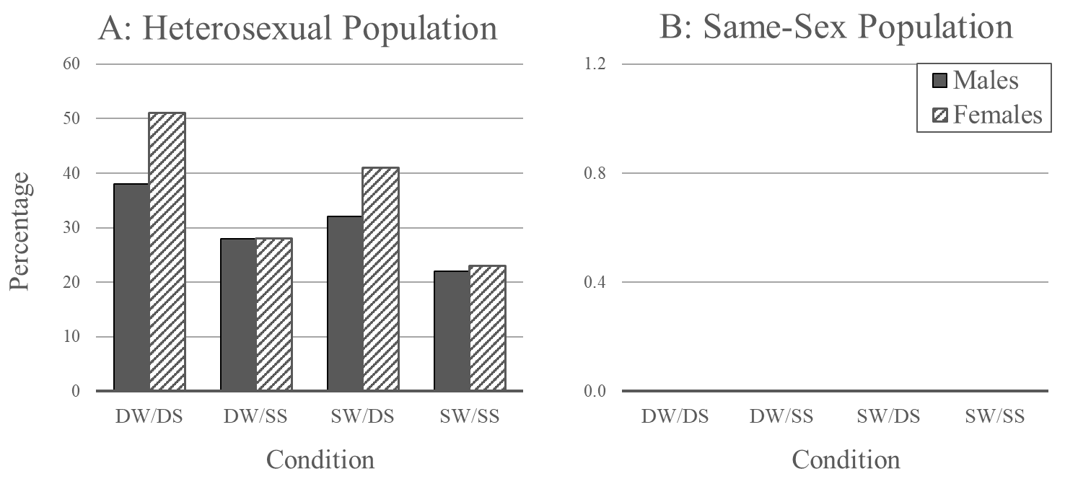

Note: Conditions are as follows: DW/DS = different willingness and different desirability standard, DW/SS = Different willingness but same desirability standard, SW/DS = same willingness but different desirability standard, and SW/SS= same willingness and same desirability standard. Standard errors are not represented in these figures, but in all cases are ≤ .001 in Panel A, and ≤ ??? in Panel B.

Figure 2: Average number of short-term mating encounters (Panel A) and unique short-term mating partners (Pamel B) for those in the heterosexual mating pool.
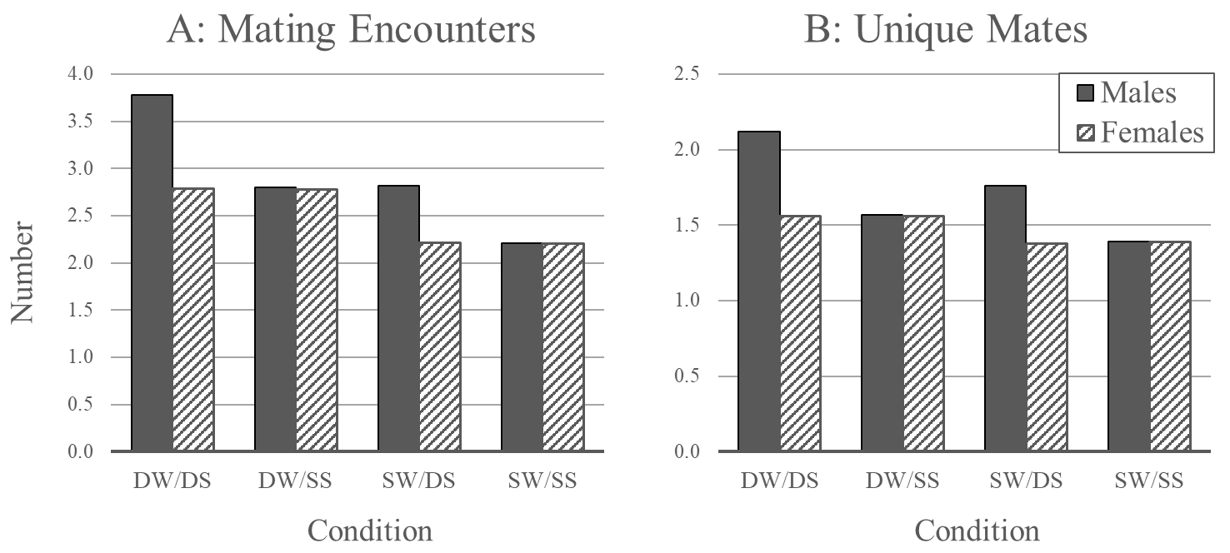

Note: The mating pool is defined as all agents with > 0 mating encounters after 1,000 Ticks. Conditions are as follows: DW/DS = different willingness to engage in short-term mating and different desirability standards, DW/SS = different willingness to engage in short-term mating but same desirability standards, SW/DS = same willingness to engage in short-term mating but different desirability standards, and SW/SS = same willingness to engage in short-term mating and same desirability standards. Standard errors are not represented in these figures, but in all cases are ≤ .01 in Panel A, and ≤ .004 in Panel B.

Figure 3: Average number of short-term mating encounters (Panel A) and unique short-term mating partners (Pamel B) for those in the same-sex mating pool.
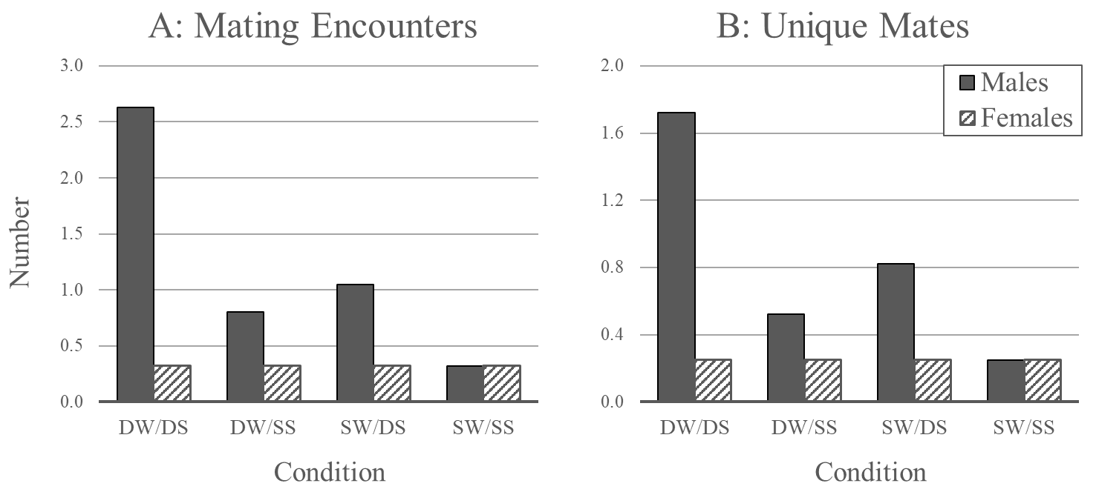

Note: The mating pool is defined as all agents with > 0 mating encounters after 1,000 Ticks. Conditions are as follows: DW/DS = different willingness to engage in short-term mating and different desirability standards, DW/SS = different willingness to engage in short-term mating but same desirability standards, SW/DS = same willingness to engage in short-term mating but different desirability standards, and SW/SS = same willingness to engage in short-term mating and same desirability standards. Standard errors are not represented in these figures, but in all cases are ≤ .008 in Panel A, and ≤ .004 in Panel B.

Note that in all of the plots, male data points are always plotted before female data points. Thus, if the two points are identical, the latter over-writes the former. This explains why, in the heterosexual case, the left-hand plots always appear as a single orange trace (the color for females); the trace for females perfectly overlaps the trace for males.
For general information about BehaviorSpace, we refer interested readers to the NetLogo User Manual at https://docs.netlogo.org/7.0.3/behaviorspace.

